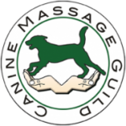
Fiona Skinner, Hollygrove Cottage, Ashley, Ringwood, BH24 2DE
T: 07717 844191 E: info@fourborders-caninemassage.co.uk

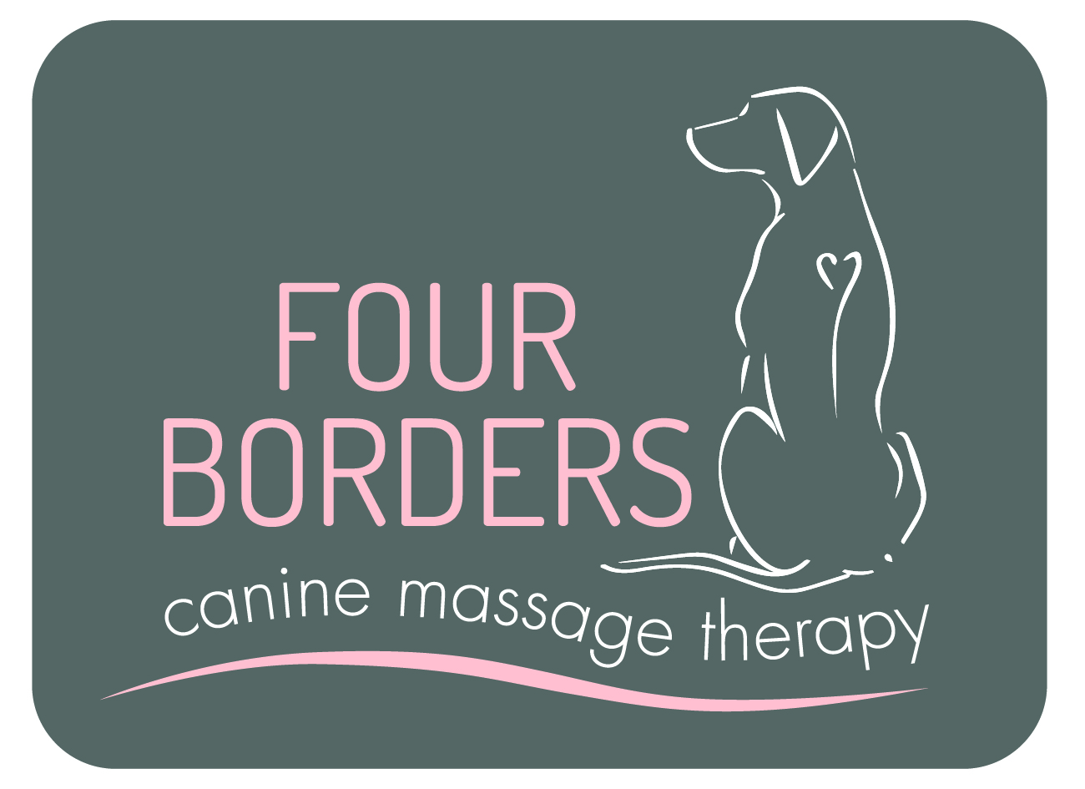
Owners Name
Address
Address |  | Post Code:
Telephone
Mobile No
Email
Dog’s Details
Name |  | Breed |  | Sex
D.O.B |  | Colour |  | Neutered

I declare I am the legal owner of the above-named dog and that all information presented is correct to the best of my knowledge. I request consent for my dog to be treated by Fiona Skinner who is a member of the professional association the Canine Massage Guild. I understand that the consenting vet or surgery shall not be held responsible, nor liable for any aspect of the Clinical Canine Massage provided by the above-named therapist.

I accept full responsibility for divulging facts that may be relevant during treatment, particularly regarding any changes in my animal’s health.

Owner Signature ……………………………………………... Print Name …...………………………………………… Date………………………………………………….

YOUR VET MUST COMPLETE THIS AREA BELOW ALONG WITH A SIGNATURE
Details of condition requiring treatment & special instructions / Areas of caution

Please attach any medical history you deem relevant
Is the dog on medication? If yes, what:
Veterinary Surgeon Name | Practice Address or Practice Stamp
If you wish to have reports emailed to you directly, please include your email address | Practice Telephone Number
I find no reason at this time why the above-named dog cannot receive Clinical Canine Massage Therapy.

Signature of Veterinarian …….……………………………………….… Print Name ……………………………………………… Date …………………….………

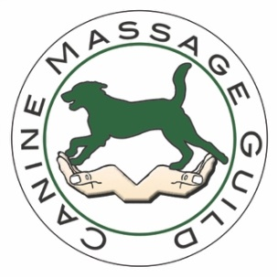
- I, Fiona Skinner, am a member of the Canine Massage Guild and I have trained for 2 Years on the Clinical Canine Massage Practitioner Programme externally accredited by LANTRA* via the Canine Massage Therapy Centre.

- My professional membership, training and credentials may be checked by visiting the online professional therapist register www.k9-massageguild.co.uk/therapistregister

- More information about me can be found on my own website www.fourborderscaninemassage.co.uk or I welcome your phone call on M:07717 844191.

- The Canine Massage Guild began participating in the world’s first clinical trials with Winchester University and Sparsholt University Centre in 2018. Please see the Canine Massage Guild website for further/latest information.

- Each year I commit to a minimum of 25 hours CPD as part of the Canine Massage Guild’s strong code of ethics and conduct.

- I hold my own professional indemnity and public liability insurance which is audited annually by the Canine Massage Guild.

- I always abide by the Veterinary Surgeons Act 1966 and Exemptions Order 2015, by never working on an animal without veterinary consent. As stated by the RCVS, “Physiotherapy' is interpreted as including all kinds of manipulative therapy” (Section 19.21), thus including massage therapy. Manipulation under massage therapy is limited to soft tissue and testing a joint’s range of motion. I do not manipulate joints like a chiropractor.

- I specialise in the use of Myofascial Release, Remedial Sports Massage, Deep Tissue Massage and Swedish Massage as well as the Lenton Method™ of Myofascial Release. More details may be found on the Canine Massage Guild website.

- I ensure continuity of client care by providing a written report back to the surgery upon completion of a client’s initial sessions.

- I comply with GDPR Compliance 2018 and the Data Protection Act 1998.

- Clinical Canine Massage Therapy is suitable for soft tissue injury rehabilitation and for the chronic pain management of orthopaedic conditions as well as pre and post-operative care. It is commonly used amongst sporting, performance and agility competitors too. If you would like an Integrated Veterinary Care Initiative educational pack on Clinical Canine Massage for your Surgery, please contact me and I will be more than happy to send one for your perusal.

*formerly Therapeutic Canine Massage Diploma accredited by Ascentis

